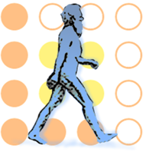
Fact sheet

Explainable Computer Vision Workshop
and
Job Candidate Screening Coopetition

Frame-Difference & Multi-Blocks for Job Candidate Screening Coopetition

10 February 2017

1. Team details
1.1 Team name: FDMB
1.2 Team leader name: Azeddine Benlamoudi
1.3 Team leader address, phone number and email:
19 Beb eldareb biskra,
Biskra 07000, Algeria
+213540178175
benlamoudi.azeddine@gmail.com
1.4 Rest of the team members: Salah Elddine Bekhouche, Djamel Samai, Abdelkrim Ouafi, and AbdelmalikTaleb-Ahmed
1.5 Affiliation: Laboratory of LAGE, University of Ouargla, Algeria

2. Contribution details
2.1 Title of the contribution: Frame-Difference & Multi-Block for Job Candidate Screening Coopetition
2.2 Final score: Not available
2.3 General method description:
- Overview of the proposed approach
The proposed approach can be divided into three phases: face preprocessing, feature extraction and Big-Five and interview traits estimation.

Face preprocessing phase:
Face pre-processing is performed in three steps, which are: face detection, eyes localization (pose correction), and face normalization. Face detection is a signiﬁcant step in face analysis. We used Viola & Jones algorithm to detect the face region and use Ensemble of Regression Trees [1] to localize the eyes positions, then the coordinates of the eyes are used to correct the face pose and resized to 128 x 128.
Feature extraction phase:
After the face pre-processing step, we get cropped and normalized faces to 128 x 128 pixels. Then the Frame-Difference [2] is computed before dividing the face into multiple blocks with MB representation using 7 level. After that, on each block, we extract features using Local Phase Quantization descriptors LPQ. We used a window of size (3 x 3), and Gaussian derivative quadrature ﬁlter for local frequency estimation. The feature extracted from all blocks of one image of frame difference are concatenated to get one feature vector. We compute the average of concatenated feature vectors of the whole video frames.
Big-Five and interview traits estimation:
We use the SVR implementation of Matlab to estimate the Big-Five and the interview traits. In brief, we train six SVRs (See Fig. 1).
- The proposed method uses / takes advantage of personality traits? No
- Coopetition: can your code be shared among other participants for the second stage of the challenge? Yes
- Total method complexity: NA
- Which pre-trained or external methods/models have been used(for any stage, if any): NA
- Which additional data has been used in addition to the provided ChaLearn training and validation data (at any stage, if any): NA
- Qualitative advantages of the proposed solution: When computing the foreground of the two successive frame, the facial features are more visible. From these remarks, we have been motivated to use frame difference in Job Candidate Screening Coopetition. This frame difference allows us to extract motion in foreground. Then the Multi-Block face representation is applied on the foreground of the frame difference that permits to obtain multiple blocks then followed by texture descriptor LPQ.
.
- Results of the comparison to other approaches (if any): NA
- Novelty degree of the solution and if it has been previously published: NA
2.4 GitHub URL for the project: https://github.com/Benlamoudi/FDMB

2.5 References:
- Kazemi, Vahid, and Josephine Sullivan. "One millisecond face alignment with an ensemble of regression trees." Proceedings of the IEEE Conference on Computer Vision and Pattern Recognition. 2014.
- A. Benlamoudia, KE. Aiadi, A. Ouaﬁ, D. Samai, and M. Oussalah. Face Anti-Spooﬁng Based-on Frame Difference and Multi-Blocks Representation. In Press.
2.6 Representative image / diagram of the method:

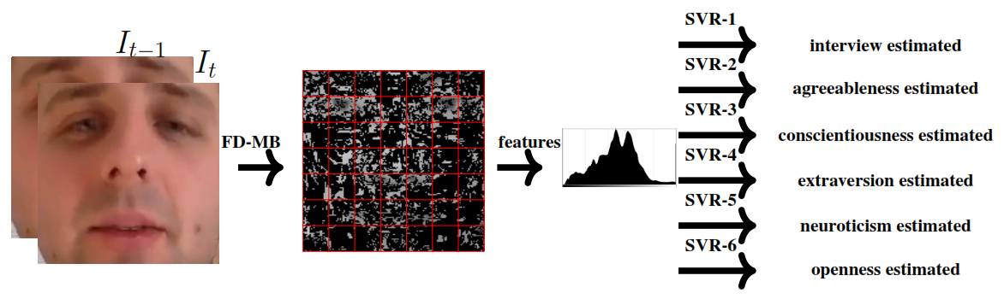

2.7 Describe data preprocessing techniques applied
We extract the difference between two successive frames which represent the motion and divided the foreground into multiple blocks, then we apply LPQ in each block.
3. Visual Analysis
3.1 Features / Data representation: LPQ with 256 features X 49 blocks = 12544 features
3.2 Dimensionality reduction: NA
3.3 Model: NA
3.4 Learning strategy: SVRs
3.5 Other techniques: NA
3.6 Method complexity: NA

4 Personality Trait recognition from Visual data
4.1 Features / Data representation: LPQ with 256 bins X 49 blocks = 12544 bins
4.2 Dimensionality reduction: NA
4.3 Model: NA
4.4 Learning strategy: SVRs
4.5 Other techniques: NA
4.6 Method complexity: NA

5 Other details
5.1 Language and implementation details (including platform, memory, parallelization requirements):
OS: Windows-10 64 bit
CPU: Intel Core™ i7-4790 CPU @ 3.60GHz
RAM: 16GB
Language: Matlab R2016b
5.2 Human effort required for implementation, training and validation? ~4 days
5.3 General comments and impressions of the challenge? what do you expect from a new challenge in face and looking at people analysis?
It's nice thanks for the organizers of the challenge but the time is very short.
7 References
- Kazemi, Vahid, and Josephine Sullivan. "One millisecond face alignment with an ensemble of regression trees." Proceedings of the IEEE Conference on Computer Vision and Pattern Recognition. 2014.
- A. Benlamoudia, KE. Aiadi, A. Ouaﬁ, D. Samai, and M. Oussalah. Face Anti-Spooﬁng Based-on Frame Difference and Multi-Blocks Representation. In Press.
- Ojansivu, V., & Heikkilä, J. (2008, July). Blur insensitive texture classification using local phase quantization. In International conference on image and signal processing (pp. 236-243). Springer Berlin Heidelberg.

